**Fruit Sorter GDD**

**Game Name:** “Fruit Sorter”

**Genre:** Casual Action (Mobile)

**Game Elements:**

The player will tap their finger on/across “paddles” to alter the path and direction of different fruits travelling down a conveyor belt to guide their movement to the correct destinations.

**Elevator Pitch:**

2D top-down casual reaction-puzzle game with cute images and bright colours designed to be played for a few minutes at a time.

**Player:**

Single-player-only, with online score leaderboards for each level.

**Technical Form:**

2D Graphics (Flat)

**View:**

Flat-view pane. Top-down 2D.

**Platform:**

iOS, Android

**Language:**

C#

**Device:**

Mobile

**GAME PLAY**

Apples, bananas, grapes, tomatoes, will be guided down a constantly moving conveyor belt by the player’s input each to a different destination hopper at the end of splitting paths. As levels progress, each additional fruit added will force the player to react quicker in the moment-to-moment gameplay, and ensure that the correct paths are aligned for each fruit, each worth a different amount of points for successfully being sorted.

Level difficulties will be divided by different accuracy requirement to pass and clear the levels; Easy difficulty will only require 40% accuracy, medium will require 60%, and hard will require 80%.  
Starting levels will only have two hoppers and one paddle to alternate, while later levels will have several paddles along the conveyor belt that will require pre-thought and planning of the paddles, as well as forcing the player to look after each conveying fruit by introducing more and more concurrently travelling fruits.

**Game Play Outline**

After downloading from an app store/website, the player will tap the game’s icon from their mobile device’s desktop to launch the game.  
After a brief splash screen animation (Impulse Squared™), the front menu will appear with the selectable options:  
*Play  
High Scores* (For the player to see their current scores for levels they have access to, and their online ranking)  
*Options* (Consisting of volume sliders for music, sound effects, and possible colour-blind accessibility alternatives)  
*Exit*  
  
Upon tapping the *Play* button, the player will be taken to a selection screen allowing them to choose which level they wish to play on. When a level is selected and confirmed, the player will be able to select their preferred difficulty see their personal high score on that level and difficulty combination before the difficulty is confirmed.

Each of the game levels will follow the theme of a differently configured conveyor belt. Each fruit that needs be sorted will be randomly generated without any pattern. Dependant on the level, a conveyor belt with up to seven ‘paddles’ is presented to the player. Each layout is unique to each level, but is static to that level and does not change. Each paddle is a binary state, blocking off a path of the conveyor belt but leaving another path open. For each paddle, the path of the conveyor belt offers a fork and split in the path.

The player achieving a “win-state” will be dependant entirely on their successful accuracy in sortin the fruits through-out the level. For easy difficulties, this will require 40% accuracy. For medium difficulties, this will be 60% accuracy. For hard difficulties, this will require 80% accuracy. Only fruits that are successfully sorted will be counted toward the player’s score. Unsuccessful fruits do not penalise the player outside of their accuracy rating.

The player failing to achieve the required accuracy per their difficulty setting choices will result in being unable to progress to the next level.  
After three consecutively failed attempts, the player will be offered a ‘pity win’.

The game ‘ends’ after 25 levels, though each level is infinitely replayable.

Enjoyment for the player is derived from the satisfaction to react and manage each fork and split in the conveyor’s path to successfully guide each fruit, making moment to moment choices across each offered paddle placement that will alter the potential outcomes of each fruit’s destination.

The story of the game is that the player is a farmer that needs to organise and sort their fruits to be ready for delivery to market. Unfortunately for the farmer-player, their farmhand has used the same harvest bins while harvesting the different varieties of fruits grown on the player-farmer’s farm, and it is up to the player to rectify the issues to their business brought about by the farmhand.

Levels will end after an allotted timespan.  
Upon completion, the player will be taken to a splash screen showing a synopsis including their accuracy. If successful, they will be able to progress to the next level straight from this screen. If unsuccessful, they will instead be able to replay the current level.  
Both win and lose states of the screen will allow the player to return to the main menu.

**Key Features**

The main features of the game that will attract players are smooth, bright, and flashy animations with whimsical, light-hearted, upbeat sound and music design. The initial attraction is eventually replaced by the intrinsic self-satisfaction of achieving a higher score and clearing harder difficulties.

**DESIGN DOCUMENT**

Game Objects:

*Conveyor Belt*  
The conveyor belt is uncontrolled by the player. The conveyor belt ferries each of the “fruits” continuously along its path at consistent speeds, terminating at several possible “bins” with designations for each fruit  
  
*Paddle*  
Paddles are binary-state barriers that the player can tap on to alternate them between two possible positions. Each position blocks off one path or split along the conveyor belt’s paths, forcing each fruit down the exposed path.  
  
*Fruit*  
*{ Apple  
Banana  
Grape  
Tomato }*

Fruit is non-interactable by the player, and constantly move along the conveyor belt’s path. The player is only able to interact with them by changing the paddles and denying their movement down the pathway that the paddle is positioned across.  
  
*Fruit Bins*  
Each of the fruit has a single bin that they are allowed to be terminated into via the above control of each paddle. Points scores are awarded for successfully bringing each correct fruit into their designated fruit bin.

**Design Guidelines**

The design of the game is to challenge the player’s reactions and ability to think ahead at a steadily increasing rapid pace. The player is restricted in their interactions, only able to interact with the binary-state paddles.  
The player should not be given any direct ability to influence the fruits, nor the conveyor belt itself.

**Development Hard and Soft requirements:**

Desktop workstation(s), Unity Engine (v.2022.3.18f), Fruity Loops.

**Visual Guide & Inspiration**

**Game Flowc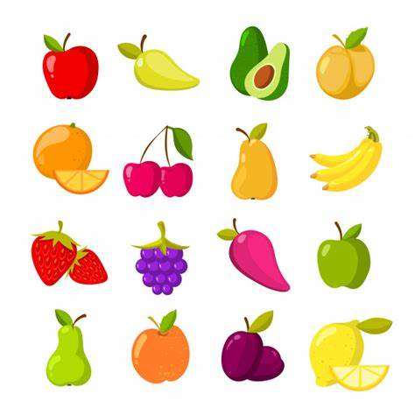hart**

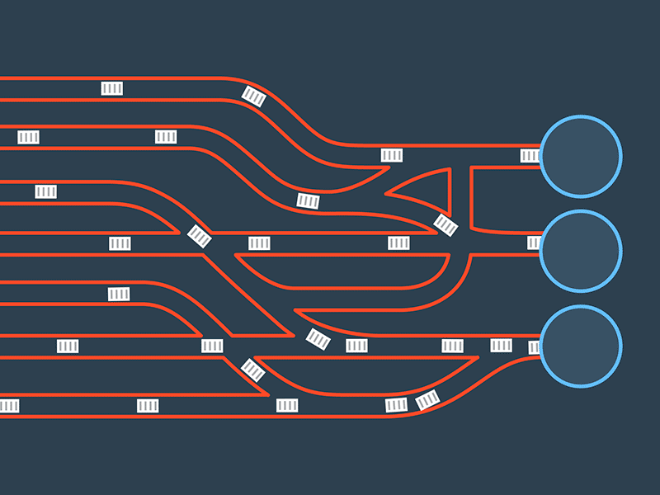

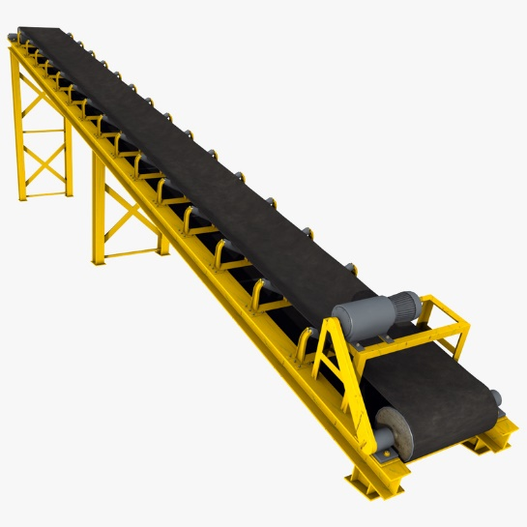should represent Object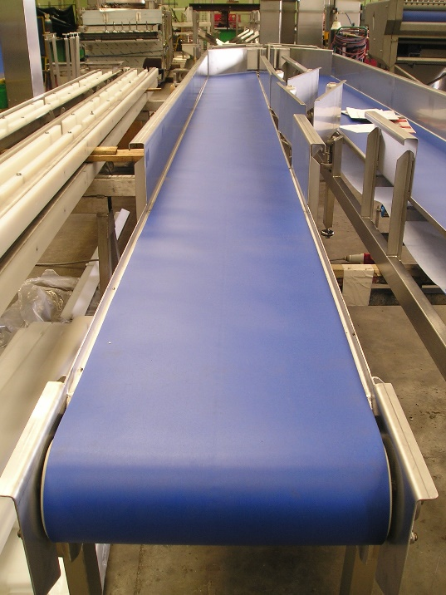s, Properties, and Actions present in the game. Each of these items should have a number reference

to where they exist within the game mechanics document.

• Menu

• Synopsis

• Game Play

• Player Control

• Game Over (Winning and Losing

Player Definition

● Use this section for quick descriptions that define the player

● Use the Player Properties section (below) to define the properties for each player. Player Properties can be

affected by the player’s action or interaction with other game elements. Define the properties and how they affect

the player’s current game.

● Use the Player Rewards section to make a list of all objects that affect the player in a positive way. Define these

objects by describing what affect they cause and how the player can use the object.

**Player Definitions**

A suggested list may include:

• Health

• Weapons

• Actions

**Player Properties**

Each property should mention a feedback as a result of the property changing.

User Interface (UI)

This is where you’ll include a description of the user’s control of the game. Think about which buttons on a device would be

best suited for the game. Consider what the worst layout is, then ask yourself if your UI is it still playable. A visual

representation can be added where you relate the physical controls to the actions in the game. When designing the UI, it may

be valuable to research quality control and user interface (UI) design information.